IC Belt System
Revised 2025


Table of Contents
Background 1
Coloured Belts 3
Specialist Competencies 7

Background
Fenix operates on a ranking system designated by coloured belts which represent levels of capability. The more capable an Independent Contractor (IC), the more profitable jobs they are able to carry out. The belt system applies to ICs only.
When a person joins Fenix as an IC, they would normally begin at the grade of white belt as defined in the Fenix onboarding process and progress through the system until reaching a higher belt at which they are comfortable. In normal cases, the highest belt to which an IC would aspire is a blue belt. Hence, there are normally three belts of interest: white, yellow and blue.
In addition, an IC may be assigned an endorsement for a specific area of specialist expertise. For example, a yellow belt IC who has achieved all of the pre-requisites in the speciality of heavy-duty steam cleaning, may be assigned a yellow belt endorsement for steam cleaning. This would be represented as an imaginary black stripe with the initials HDSC on an imaginary yellow belt as shown below.
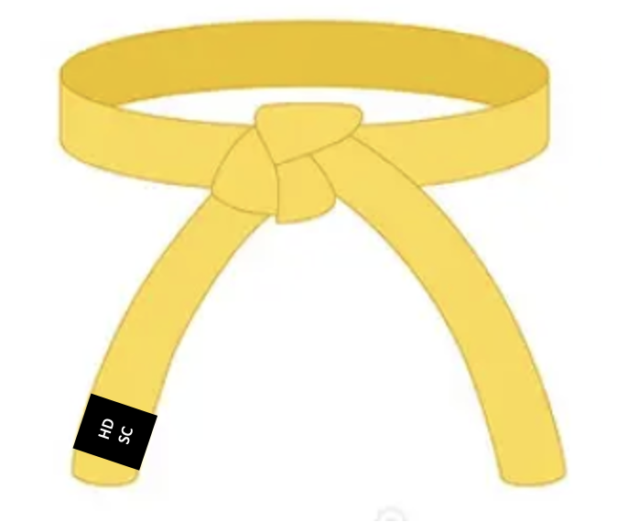

Similarly, a blue belt with proficiencies in high-pressure cleaning (HPC) and mould cleaning (MC), would be as shown below.
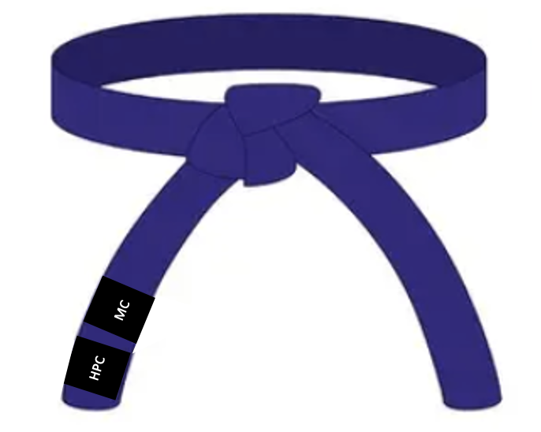

As a staff member passes from one belt to the next, they may receive a certificate and a small gift to commemorate the occasion – see Annexure 1.

Coloured Belts

White Belt
Level | Belt | Reward | Typical Skills | Typical Job Characteristics
1 | White | White Belt Certificate (not issued) | Cleaning:  Training – Completed T3 Basic Cleaning  Basic cleaning skills  Business:  Has a basic knowledge of SM8  Can submit a reasonably correct invoice  Maintains a white belt inventory | New recruit  Assistant cleaner on any job  Working alone but under supervision with mandatory QA checking  Non-VIP jobs  Non-complex jobs  May call on Fenix for assistance and advice during a job

Yellow Belt
Level | Belt | Reward | Typical Skills | Typical Job Characteristics
2 | Yellow | Yellow Certificate and  $50 gift voucher | White plus…  Cleaning:  Advanced cleaning skills  Business:  Able to quote fairly an own unquoted basic job*  Has a good working knowledge of SM8  Can submit a correct invoice on most occasions  Has a working knowledge of PPE and safety  Often owns a problem and problem solves  Maintains a yellow belt inventory  * A basic job means Vacate, Move-in, Settlement, Wipe-over | White plus…  Management of a basic job with QA checking at supervisor discretion  VIP jobs with mandatory QA checking  Reasonably complex jobs  Rarely calls on Fenix for assistance and advice during a job

Blue Belt
Level | Belt | Reward | Typical Skills | Typical Job Characteristics
3 | Blue | Blue Certificate  and  $100 gift voucher | Yellow plus…  Cleaning:  Expert cleaning skills  Business:  Able to quote fairly a basic job on business hours*  Able to quote fairly an own unquoted complex job**  Has a superior knowledge of SM8 and can coach others  Can always submit a correct invoice  Has a superior knowledge of PPE and safety and can coach others  Usually owns a problems and problem solves  Demonstrated basic up-selling and cross-selling skills  Maintains a blue-belt inventory  * A basic job means Vacate, Move-in, Settlement, Wipe-over  ** Presale | Yellow plus…  Management of a basic job from start to finish without QA checking  Management of a complex job from start to finish with QA checking at supervisor discretion  VIP jobs with QA checking at supervisor discretion  Very complex jobs  Almost never calls on Fenix for assistance and advice during a job

Specialist Competencies
Refer to Informational Document – Job Types

Annexure 1
